1. created 2-vpc , launched 2-instaces

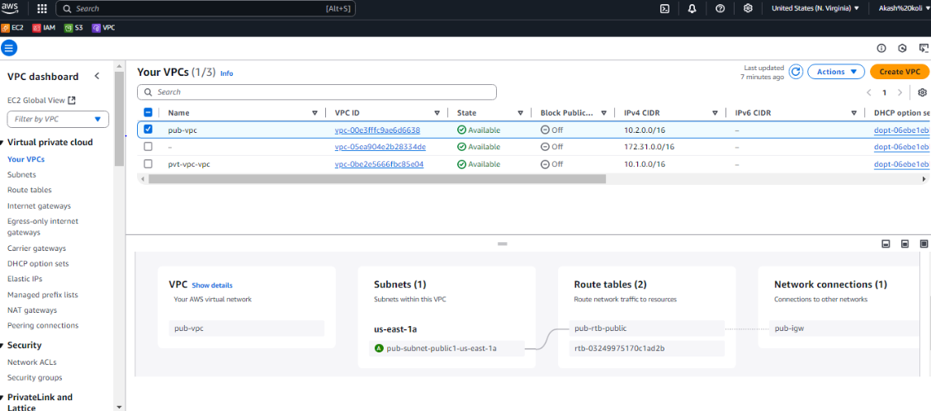

1. after creating peering connection getting response

